# DSS components

Patient selector

populated via reading patient folders on server

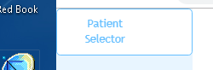

When selected - makes call to main.go to read server data, construct arrays of server data.

Current arrays:

type Data struct {

OrganList []string

PlanList []string

DDVHarray [][][][]float64

}

Future arrays – patient CT data, 3D-dose data

These are implemented in app.js

## Roi Buttons

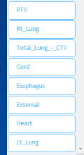

Dynamically updated based on Organ list, each button updates the “treatment range” graph and the “Tradeoff graph”

## Treatment Range graph and the Tradeoff graph

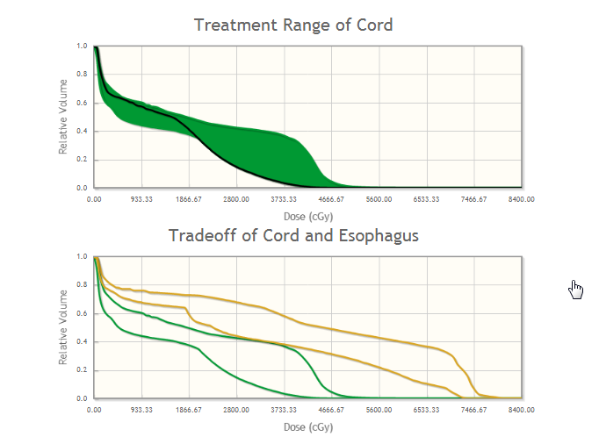updated for a single ROI – shows upper / lower bounds of ROI DVH and where the current plan sits (in black)

## Interactive DVH

Currently the only way to update selected plan is the “drag/drop” method of this interactive DVH plot

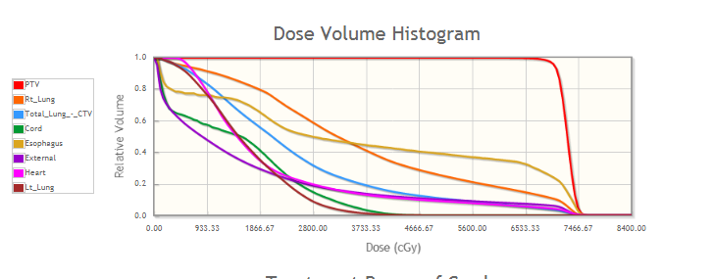

NTCP = Normal Tissue Complication probability

Bars

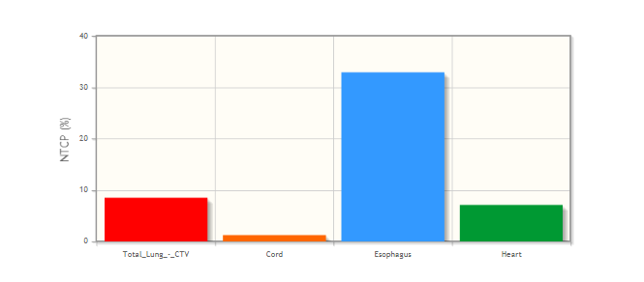

## A dicom Viewer

Beginnings of a dicom viewer using “Cornerstone” javascript libraray

